**How you and/or your team can participate in a whole of water sector IDAHOBIT Day video**

* Reflect on the following 2 questions:

1. How does the theme "No one left behind: equality, freedom, and justice for all" resonate with you?
2. Considering the theme "No one left behind," what actionable steps do you believe we can take in the workplace to promote equality, freedom, and justice for all?

**Record yourself:**

* Print out your answers on A3 paper OR video yourself verbally answering. (Answer could be a drawing or symbol – just make it large enough to see or captioned)
* Using the back camera, take a picture of yourself with your printed answer. (If the picture is taken as a selfie, the text will show up as reversed)
* Capture the photo in a setting that exudes comfort and positivity, whether indoors or outdoors.
* Example pictures are below, recommended font size 60 & dark text colours.
* Send your photo/video **no later** than **10 May 2024**.

To: [enquiries@iwn.org.au](mailto:enquiries@iwn.org.au)

**Additional tips:**

* Film or take image in landscape mode
* If you can, use a tripod or set up the phone/camera in an area where it won’t move.
* If taking motion shots move the camera slowly, no sudden movements.
* Put your camera app in the highest quality setting.
* Video length should be short, keep it under 1 minute.
* Upload any files without compression if possibly, directly to a OneDrive or cloud storage for easy transfer.

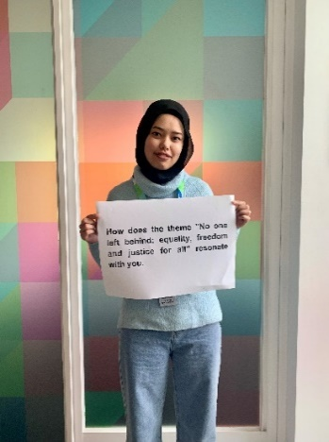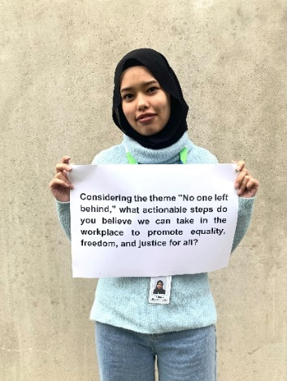

Note : photo image is portrait - please use LANDSCAPE mode.